Software Requirements Specification

Version 2.0

December 06, 2016

**Campus Tour Software**

Chitturi, Rakesh

Dande, Mallikharjuna Rao

Kotu, Chiranjeevi Sneha

Parimi, Teja

Prodduturi, Nayan Reddy

Solasa, Vamsi Krishna

Submitted in partial fulfillment

Of the requirements of

CSIS44-691 Graduate Directed Project 1

**Table of Contents**

Contents

1.0. Introduction 1

1.1. Purpose 1

1.2. Scope of Project 1

1.3. Glossary 1

1.4. References 1

1.5. Overview of Document 2

2.0. Overall Description 3

2.1 System Environment 3

2.2 Functional Requirements Specification 5

2.2.1 Application Home Screen: 5

2.2.2 The Campus Tour 6

2.2.3) Error Flow 8

2.2.4 QR Scan 8

2.2.5 Approaching Building Use Case 11

2.2.6 Offline Tour 12

2.2.7 Password Reset 13

2.2.8 Add Building: 14

2.3 User Characteristics 15

3.0. Requirements Specification 16

3.1 External Interface Requirements 16

3.2 Functional Requirements 16

3.3 Detailed Non-Functional Requirements 19

3.3.1 Logical Structure of the Data 19

3.3.2 Security 19

Privileges to add or update events and building data should be available to only respective university DBA and should be well protected using variety of security measures 19

# 1.0. Introduction

## 1.1. Purpose

The purpose of this document is to present a detailed description of the Campus tour application developed to run on Android OS (version 4.0 and higher). It will explain the purpose and features of the system, the interfaces of the system, what the system will do, the constraints under which it must operate and how the system will react to user input. This document is intended for both the stakeholders and the developers of the system and will be proposed to the client for approval.

## 1.2. Scope of Project

This will be an android application for users the campuses which are enrolled to the application (enrolment procedures will be explained in detail in later part of this document). This application will be designed to maximize productivity by aiding users to take a tour of the campus of universities which would otherwise be a tedious task. By understanding the users need this application will be productive and useful to the users.

The audience will be the prospective students or their parents who want to get familiar with the infrastructure and the facilities provided at different locations in the university. This application is designed to allow the user to scan the QR Code of the building and get to know the details of the buildings in the campus and to keep a track of buildings visited with the help of a map using GPS. This software will facilitate communication between users GPS and campus buildings.

## 1.3. Glossary

|  |  |
| --- | --- |
| **Term** | **Definition** |
| DBA | Database administrator |
|  |  |
|  |  |
|  |  |
|  |  |
|  |  |
|  |  |
|  |  |
|  |  |
|  |  |
|  |  |
|  |  |
|  |  |

## 1.4. References

IEEE. *IEEE Std 830-1998 IEEE Recommended Practice for Software Requirements Specifications.* IEEE Computer Society, 1998.

## 1.5. Overview of Document

The next chapter, the Overall Description section, of this document gives an overview of the functionality of the product. It describes the informal requirements and is used to establish a context for the technical requirements specification in the next chapter.

The third chapter, Requirements Specification section, of this document is written primarily for the developers and describes in technical terms the details of the functionality of the product.

Both sections of the document describe the same software product in its entirety, but are intended for different audiences and thus use different language.

# 2.0. Overall Description

## 2.1 System Environment

Main Components:

1. Map Interface
2. Building details interface
3. Campus tour application
4. Back4App Database
5. Super user
6. University Administrator

The system is the campus tour application running on the Android phone.

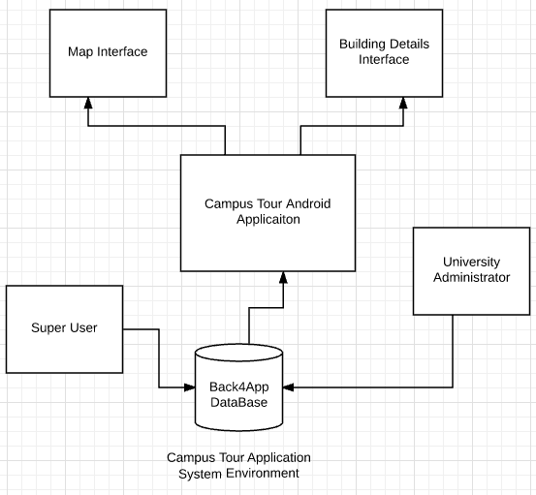

Figure 1 - System Environment

Our Assumptions about the client environment include

1. Internet connection
2. GPS functionality
3. Compatible with Google Maps application
4. Android OS version of 4.0 (Ice Cream Sandwich)

## 2.2 Functional Requirements Specification

The purpose of the application is to give a campus tour of University selected by the user.

This section outlines the use cases for each of the each scenario separately.

### 2.2.1 Application Home Screen:

Upon launching the application form the applications list the app displays a prompt to select a university campus, once a university is selected the application connects to the database, downloads the campus related information, and loads the map with the universities location.

**Initial Step-By-Step Description**

1. Clicks on the application from applications list in their mobile.
2. Application launches with main page showing to select a campus.
3. User selects a campus and the application connects to database via internet to fetch data regarding the selected campus. This is a mandatory step and user cannot proceed without selecting any campus. a popup will be thrown to alert and make the user to complete this step.
4. If the attempt to connect to internet fails, the user is alerted of failure and suggests to try again.
5. 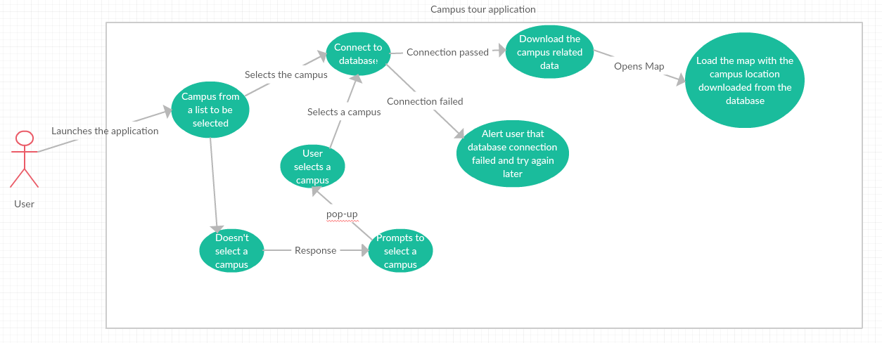Once the download is complete the application opens the map interface and loads the map with the campus location downloaded from the database.

### The Campus Tour

**Brief Description:** Once the user is on the home screen he has two options one to start a physical tour, and other to start a virtual tour.

**Physical Tour:** In this tour the user is present at the campus and moves around the campus’s buildings carrying the mobile phone. User can scan the QR codes spread all over the campus (Pre-placed by the university authorities on each building, the QR will be generated when the university DBA adds a building to the campus). This tour keeps track of users via GPS coordinates and Google Location services which are built in to the Android OS. The QR codes scanned would be checked against the GPS coordinates for accuracy. If they don’t match then the application displays error message and then displays the information of building based on the GPS coordinates for that instance.

**Virtual Tour:** This tour doesn’t require the user to be present on the campus and shows the campus overview and can check out building’s details from the map interface. This tour doesn’t need any voice assist as user won’t be moving physically from one building to another. But the details of buildings will be provided same as in physical tour.

#### 2.2.2 a) Virtual Tour

**Step-By-Step Description**

1. User enters the home screen
2. Two buttons are shown
3. Clicks on Virtual tour
4. Application loads the map, Zooms out to campus overview
5. Campus overview shows all marked buildings downloaded in first step (Pre-determined and loaded into database by the database administrator)
6. User can click on POI to view its details.
7. Clicks on end tour to go back to the main home page in step 1.

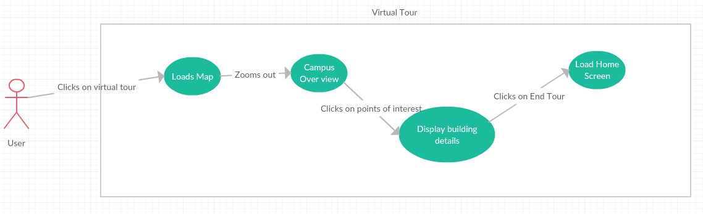

#### b) Physical Tour

**Step-By-Step Description**

1. User enters the home screen.
2. Clicks on Physical Tour button.
3. The application gets the user location from the location services and opens the map and marks the current location of the user.
4. The path is pre-determined (DBA sets it and app downloads it in the beginning) and the app starts the tour from nearest location to the user.
5. When the user approaches a building the application gives audio feedback on where he/she is and gives audio feedback on the destination building in the path and directs to its QR code location.
6. 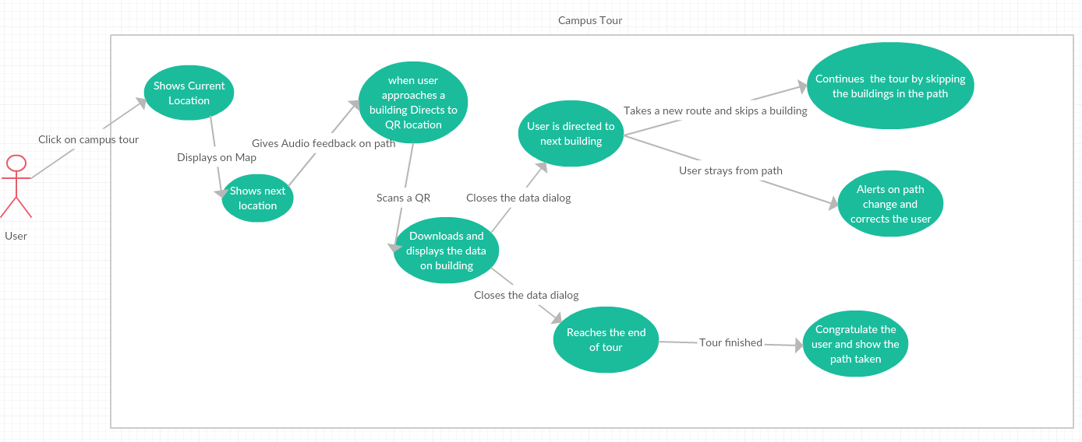Once user scans the QR code the app displays the information of the building and if it finds any audio and video data on the building it displays them too.

### 2.2.3 Error Flow

**Brief Description**

This use case describes about the error flow in the application. When the user disconnects from the network or goes away from the given direction.

**Initial Step-By-Step Description**

1. The user goes away from the path.
2. Alert the user about the path change.
3. After alerting the user the application gives the user the correct directions to the path.
4. When the user is in the correct direction as shown in the map the tour is resumed.
5. The second scenario is when the user disconnects from the network.
6. The application notifies the user when he is disconnected from the network asking him/her to connect to the network.
7. The application prompts the user to enable data.
8. 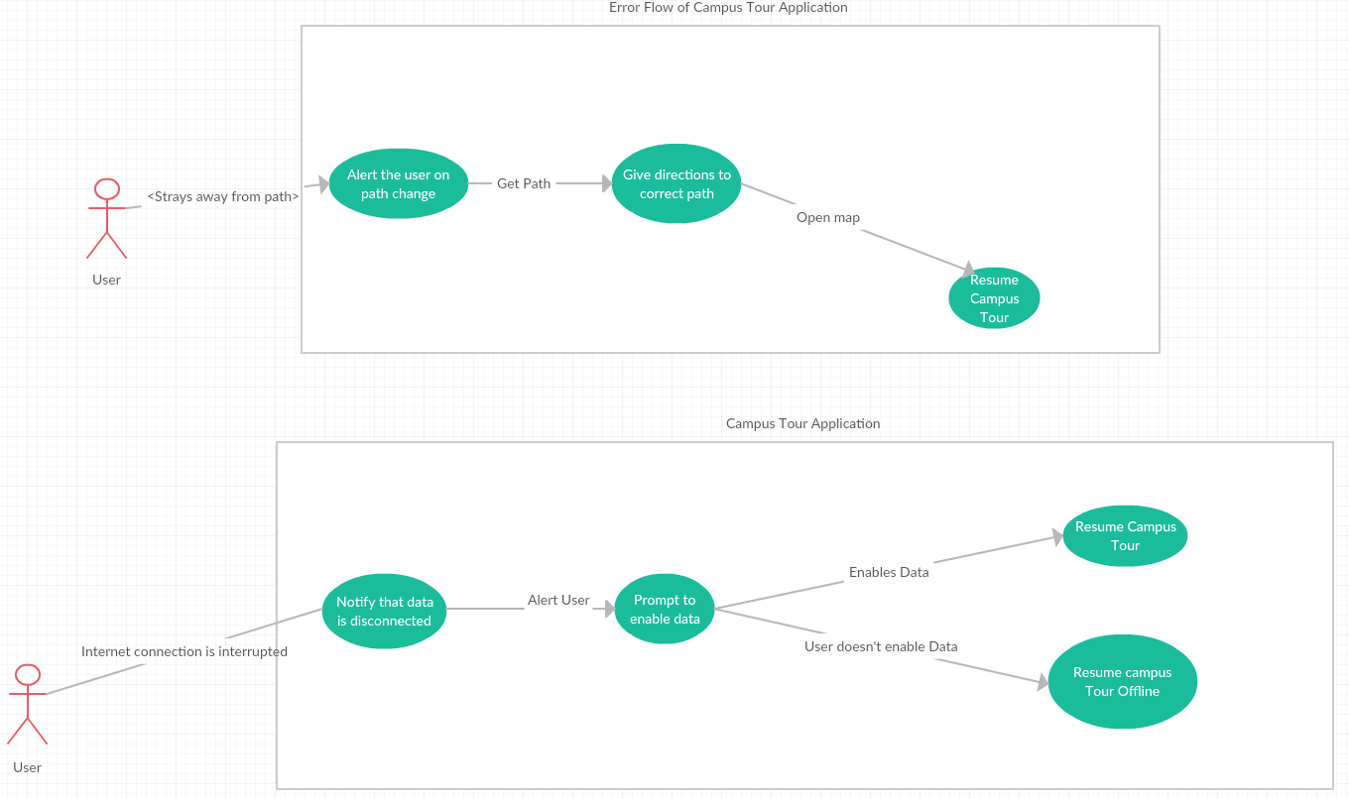After the user enables the data the application resumes with the campus tour.

**Use case: Error Flow of Campus Tour**

### 2.2.4 QR Scan

**Brief Description**

This use case describes about the QR Scan code. This gives a detailed description of how the user will scan the QR code and the functionality of this feature.

Note: QR Code will be generated using GOQR.me API first when the building is added to database and a new QR will be generated whenever the building name (and building name only) gets changed/updated.

**Initial Step-By-Step Description**

1. User approaches a QR code on the building
2. Launces the QR camera from side menu options
3. Scans the QR code
4. Application processes the QR code
5. Launches the activity corresponding to the QR code
6. During the initial step when user selects a campus the app downloads the pictures and text data of all buildings in this step it downloads any video or audio data for this building and shows the result in a window
7. If QR scanned is invalid the app prompts the user to scan in once again
8. Even for the second try the QR scanned is invalid then the app prompts to close the application and open it again to fix the issue.
9. If Any audio data is present and if the user clicks in read out loud button the app reads out the audio information
10. If any video data is present, the user can view it by clicking on the video
11. 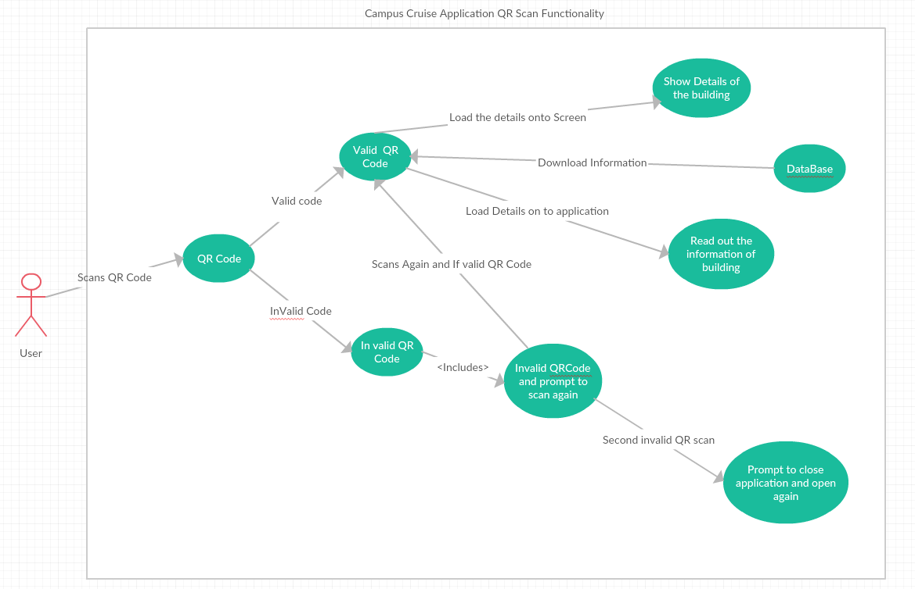 On the other hand, if no data is found a tag is displayed with message <No data present for this building.

**Use case: QR Scan Functionality**

### 2.2.5 Approaching Building Use Case

**Brief Description**

**Initial Step-By-Step Description**

1. User approaches a building, the app issues audio information saying that the user is nearing a building, tells in which direction the building is and directs to the QR code location of the building.
2. User approaches two buildings, Application senses the borders of two buildings
3. Issues audio information of approaching buildings
4. Directs to the nearest building and once user finishes viewing the building direct to next building.

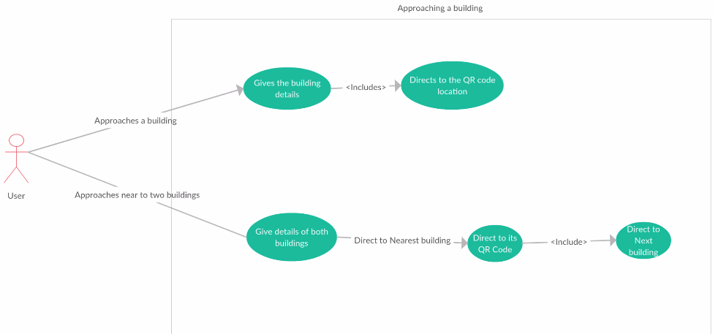

**Approaching Building Use Case**

1. Apart from the regular campus route there would be additional building in campus which could be visited if the user chooses to.
2. When user approaches a destination, which is near these optional buildings the application should ask if the user wants to visit this in the campus tour or not then the user can proceed with the tour if he chooses not to.
3. If the user is interested in visiting these buildings, then these buildings will be added to the user’s campus tour.
4. If the user wants to go to the additional building he can choose to opt for that route or can continue the tour in the predefined route

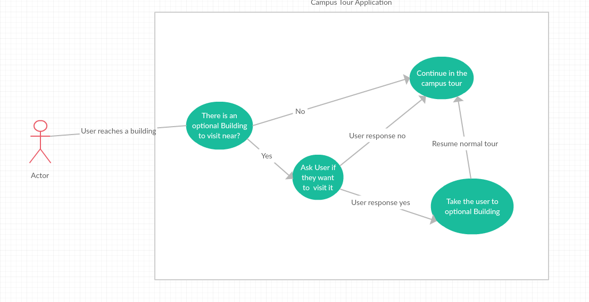

**Optional Tour Use Case**

### 2.2.6 Offline Tour

**Brief Description**

This use case describes about the Offline Tour, When user has internet or GPS disconnection the app senses it and in case user is unable to restore the connection the application goes to offline mode. In offline mode, the tour is reduced to key point of interests only and doesn’t have the audio feedbacks.

**Initial Step-By-Step Description**

1. App loses the connection to internet
2. App prompts the user to connect to data
3. If step 2 fails convert to offline mode
4. In offline mode show only the key points of interest. NO QR scan functionality in case of internet connection failure.
5. When user clicks on a building app shows building details.
6. 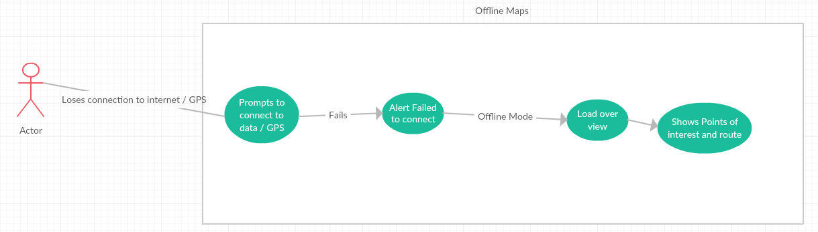When user clicks on end tour it takes the user back to home screen showing the over view of campus map.

### 2.2.7 Password Reset

**Brief Description:**  
 when the university DBA forgets his password, locks his account or wants to reset his password they will have an option to change it through the database interface (the web page where they log in to update the database.

**Step by Step Description:**

1. University DBA connects to the interface.
2. Clicks on Forgot password link
3. Answers security Questions and if they are correct then password reset window appears.
4. User types in new password and submits.
5. If user forgets their security questions they need to contact the Super user (details will be provided in the interface, prove they are who they are by giving their information along with clearance(email) from their superiors for password change).
6. Super user resets the password and provides them with new password which would then be changed on first logon.

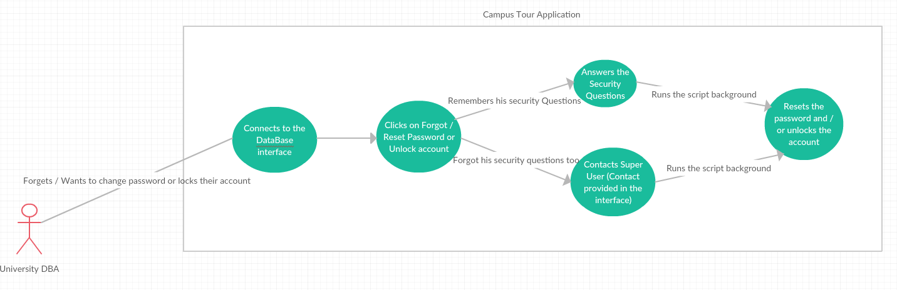

**Use case Diagram: Forgot Password**

### 2.2.8 Add Building:

**Brief Description:**  
 This use case discusses about the interface through which the university DBA adds a building and its details to the university campus. Once the building is added to database a QR code would be generated. QR code would be generated based on building name using GoQR.me API. In case the building data is being updated then QR won’t be generated. If building name changes then new QR code would be generated and the old QR becomes invalid.

Note: university DBA cannot add a university they can just update the campus details, and building details.

**Step by Step Description:**

1. User connects to DBA interface and logs in using their credentials.
2. In the home page, user clicks on Add Building button and the page containing add building loads.
3. DBA enters the details like Building name, Location, Key features.
4. Then the user adds links to resources like images, audio and video pertaining to the building and clicks on submit.
5. Application validates the data (to protect databse from injection attacks and invalid characters, duplicated building details etc).
6. After validation, the details will be added to database and a QR code will be generated.

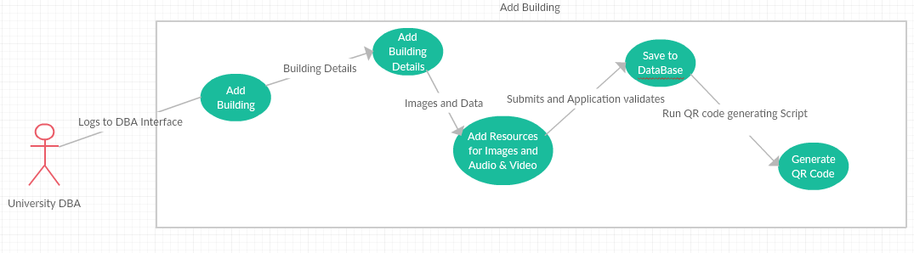

**Use Case: Add building and its details.**

## 2.3 User Characteristics

**Application User –** End user of the app takes campus tours.

**Database Administrator – Super User** – Adds Universities to the Database and defines a university database administrator for it.

**Database Administrator - University Administrator –** Adds, updates or removes what the application user views. Has access to the interface of database to change the data. Has access to only assigned university’s data.

3 The final deliverable is an android application which does the following Functions

The Android application should provide a campus tour to students:

1. Map driven interface.
2. QR Code on each building which would be scanned to retrieve and display data about the building.
3. GPS Integration to detect user’s location and work on user’s tour accordingly.
4. Should give voice assistance during navigation.

**R1.** The purpose of the application is to give a campus tour of University selected by the user.

**R2.** User will make the campus selection as first step after they launch the application from their android mobile phone.

**Campus Tour:**

**R3.** The Android application will provide two kinds of campus tours as its core functionalities

**R3.1.** The two tours provided are namely – Virtual tour and Physical tour.

**Physical Tour:** Where the user moves around the campus’s buildings carrying the mobile phone. User can scan the QR codes spread all over the campus (Pre-placed by the university authorities on each building which would be displayed in tour by university authorities specifically for this application). This tour keeps track of users via GPS coordinates and Google Location services which are built in to the Android OS the QR codes scanned would be checked against the GPS coordinates for accuracy.

**Virtual Tour:** This tour doesn’t require the user to be present on the campus and shows the campus overview (which will be downloaded from the database once user selects the campus in first step reference **R2**). This tour doesn’t need any voice assist as user won’t be moving physically from one building to another. But the details of buildings will be provided same as in physical tour.

**R3.2.** In the physical tour the application should navigate user from one building to another giving voice assist on details of points of interest along the path like approaching buildings, any monuments and current news.

**R3.3** The current news to be displayed will be fetched from database. The University DBA will update the database with the news via DBA interface (DBA interface will be discussed in later parts of this document) if there is no news to display the application will skip this part.

**R3.4** Once the Tour completes, the Application should show the map and draw route which user took during that tour. (Called Trace Route)

**R4.** The application should show the campus map with all the buildings and parking lots in and around the campus. The campus area would be stored in database as GPS coordinates with each building as subset within this area.

**R4.1** The data should be saved in cloud database hosted by back4app.com. The data to be stored would be information (Including but not limited to) Campus name, Campus details, Geo Area (area converted into Latitude and Longitude format), Building Name, Building Details, and Geo Area of the building and URI of audio, video and image resources referencing the building. Campus tour path as array of coordinates and the building names corresponding to those coordinates.

**R4.2** The Campus and building data would be entered to database by authorized University DBA via the DBA Interface.

**R4.3** The data would be stored in a NoSQL format in back4app servers and would be retrieved as JavaScript Object Notation (JSON) format which would be parsed in android application.

**R5.** The application should allow users to do the following operations in campus tour,

**R5.1.** Let the user decide the starting point of the tour.

**R5.2** When the user clicks on Start tour, the application should get the user’s location using Location services and GPS to find the user’s current location, then fetch the tour path from database, Find out nearest starting point in the path to the user there as first destination.

**R5.2.1** The Application should direct the user to the Building’s QR code location when they approach the building in course of campus tour.

**R5.3** The main route of the tour will be dependent on the campus.

**R.5.3.1** The route will be predefined by the administrator, but the starting point of the tour will depend on the user. While the end point being the building prior to the starting point in the buildings list.

**R5.3.2** The application checks the user’s location and the nearest building in the pre-defined tour would become the starting point of tour once user starts the tour.

**R6.** The application should be able to provide a virtual tour of the campus to the user. The user can observe a view of the main campus map with all the buildings information in a predefined path to know the infrastructure of the campus.

**R7.** The application should be able to scan the QR Code placed outside the building to retrieve the information of the building and its details from it.

**R7.1** The QR code will consist of text code of the building and will be generated when the university DBA adds a building to the campus using the DBA interface.

**R8.** QR Code is placed outside all the buildings on campus. The application scans the QR Code, gets the building name from it and fetches details of the building from database like the URI of image, audio, video data and loads them on to the screen.

**R9.** The GPS in the system is linked with the QR Code and both function accordingly to determine the user’s location and building visited this would be particularly useful when user is visiting buildings in close proximity.

**R.9.1** The user starts the tour with the help of the GPS maps and reaches his destination of one stop then he will scan the QR code of that building and then all the details of the building will be shown to him like the name, departments in the buildings which are stored in the database, which will be retrieved when the user scans the QR Code.

**R.9.2** When the user resumes the tour from another location the GPS is then enabled and he continues the tour till he reaches the next destination and repeats the same process of scanning the QR code for the building information.

**R9.3** If user skips a point and goes to other location in the tour then the tour should skip the missed points.

**R10.** The application should detect the internet connectivity. The different scenarios are given here

**R10.1** If there is no internet connection the application should display a message to the user asking them to connect to internet for starting/continuing the tour.

**R10.2** If there is a valid proper internet connection, then the user proceeds with the tour.

**R10.3** If the GPS or Location services are disabled a message should be displayed to the user asking them to enable GPS or Location services to continue the tour or switch to Virtual tour mode in which the user doesn’t need those services.

**R11.** If the user is not in the range of the selected campus (selected in first step once they launch the application), then application should prompt the user to either go to the campus or display option to take a virtual tour.

**R12.** If User selects to go near the campus it should direct them to the campus.

**R12.1** If the user chooses virtual tour then the application would launch virtual tour interface.

**R12.2** If user doesn’t make any choice (closed the dialog) then the application would take the user back to first screen asking them to select university.

**R13.** There should be an entry in database for each University to store data for the application to access.

**R14.** The application is based on the push pull kind of a mechanism. Which means it pulls the information from the database and pushes it to the user interface so that the user can access it and get to know about the campus being toured.

**Database Administrator Interface:**

The DBA user interface would be a Web based application running on Node.js, HTML, CSS and JavaScript. It would be connected to back4app servers.

**R.15** There are two kinds of Administrator level users Namely Super user and University Database administrator (university DBA).

**R15.1** Super user adds or removes universities to database and creates its database administrator

**R15.2** University administrator can add or delete data on university but won’t be able to delete the university or themselves. Data the DBA can add or update would be a building and details of the building, Images and information about the building and current news happening around the building.

**R15.3** The Web application should show the university data related to the university DBA thus abstracting other universities’ data between DBAs.

**R15.4** Only Super user can delete university and its DBAs. And Super user cannot delete themselves from the system.

**R.16.** Each University campus has its own DBA who adds removes or updates data and have access to only their assigned universities data. Universities with multiple campuses can have one University DBA for all campuses if they choose not to, they can have different DBAs for each campus.

## 3.3 Detailed Non-Functional Requirements

### 3.3.1 Logical Structure of the Data

* Campus stays on the top of hierarchy
* Under campuses comes the buildings
* Each building has text, audio and video data. (can have no data too, “No data” will be displayed in this case)

### 3.3.2 Security

Privileges to add or update events and building data should be available to only respective university DBA and should be well protected using variety of security measures